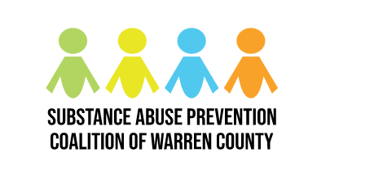
Substance Abuse Prevention Coalition of Warren County

Monthly Meeting Minutes

Date: October 5th, 2023
Time: 9:00-10:30 am

In Attendance
Miranda Lamb, Maria Dickson, Amanda Peterson, Jackie Hunter, Jodi Stone, Nichole Worthington, Barry Riley, Nancy Eigel-Miller, Joel Jacobs, Steve Brady, John Hitchens, Brian Russ, Heather Moore, Carol Lucio. Morgan Liddic, Robert Peeler, Tim Tepe, Madison Martin, Michelle Westerkamp, Mindi Doolin, Jennifer Landry, Jennifer Hoffman, Kim Sellers, Lisa Cayard, Lori Phelps, Laura Loftin, Barbara Adams-Marin, Paige Russell, Amber Spaeth, Carissa Piper, Ann Brock, Vikki Stickelman, Shelley Brown, Michele Robinette

Mission Statement

Partners working collaboratively to prevent the misuse of alcohol, tobacco and other drugs by youth and adults in Warren County and to build healthy communities by increasing protective factors, reducing risk factors and sharing resources.

Meeting Notes
- Breakfast and networking provided from 8:45-9:00 am

- Shelley kicked off the September meeting by reintroducing the resource table and breakfast, the coalition mission statement, and the meeting set-up. Coalition members sat at tables based on the committees they are participating in.

- Michele Robinette, Treasurer, gave an update on the budget. We just began a new grant cycle on Sept. 30th.

- Morgan Liddic, Butler Behavior Health, presented to the coalition on the what, how and who of their program. They have a mobile crisis program that responds to youth crisis events throughout the county. Morgan discussed the BBH screening process which includes a risk assessment on risk factors vs risk state, risk assessment considerations, and disposition. They offer a 4-6 weeks skill building program.

- Shelley went over the Ohio Coalition Institute requirements and coalition development work. She facilitated the required SWOT (Strengths, Weaknesses, Opportunities, and Threats) analysis which was done in small groups and discussed as a large group. This information will be condensed based on everyone’s input and submitted to OCI.

- Shelley discussed the plan to work smarter and not harder within the committees. Each committee has been approved for a $500 budget to begin working on some of the goals/objectives/events that they have outlined in previous coalition discussions.

- The remainder of the time was allotted to discussions within the committees and networking.

- The next coalition meeting will be the Drug Task Force presentation on the State of Warren County – you don’t want to miss it!

Action Steps
- Join a committee! Be thinking of ways you would like to get involved in the work of the coalition – how would YOU spend $500 to address substance abuse?
- Send Shelley event info and numbers of participants for ANY substance-related work you do. Teaching a class in a school, info tables at events, forums/town halls, all of the partner work everyone does counts toward our goals!

Starting in December: Meetings will be shortened to ONE HOUR long, and the time after is reserved to work in the committees!

Next Meeting
November 2nd | 8:30-10:30am
Faith Building Church
875 Covenant Way, Lebanon OH 45036
*Breakfast will be provided by Target

