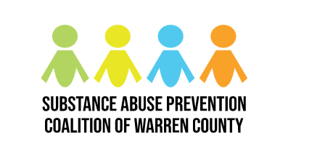
Substance Abuse Prevention Coalition of Warren County

Monthly Meeting Minutes

Date: August 3, 2023
Time: 9:00-10:30 am

In Attendance
Barry Riley, Miranda Lamb, Donna Davis, Josh Jowers, Avery Cuthbertson, Vikki Stickleman, Tracey Funke, Dustin Ratliff, Robert Wendling, Madison Martin, Abby Wallace, Caitlyn Wagonfield, Roy Lutz, Robert Peeler, Heather Moore, Samantha Gray, Brian Russ, Kevin Harleman, Adrienne Sanders, Stephen Hill, Jennifer Landry, Katie Wolf, Victoria Billman, Jennie McConnaughey, Lori Phelps, Laura Loftin, Gloria Kinney, Shelley Brown, Erica Norton, Sarah Sawmiller, Arla Tannehill, Rich Bertagna, Tim Tepe

Mission Statement

Partners working collaboratively to prevent the misuse of alcohol, tobacco and other drugs by youth and adults in Warren County and to build healthy communities by increasing protective factors, reducing risk factors and sharing resources.

Meeting Notes
- Breakfast and networking provided from 8:45-9:00 am

- Shelley kicked off the August meeting by reintroducing the new resource table and breakfast. If you have resources for the coalition, bring them! She also shared a picture of her ADORABLE grandson (Go GiGi!!)

- Shelley announced Vikki as the new co-chair. Vikki shared her story and how she got connected with SAPC. Vikki then led the group in an icebreaker activity as her first act as co-chair.

- Shelley gave an update on all of the summer events that the coalition participated in. She said if you want to participate in an event or start something new, let her know and send pictures of stuff that you do so it can go in the newsletter!

- Shelley Brown read everyone the coalition mission statement to remind us all of the work we are here to do.

- Shelley went over the structure of the executive committee so that everyone knows who is helping to make coalition decisions based on polls from members.

- Shelley gave an update on the budget and reminded us that we will start a new fiscal cycle in October. Drug Task Force money will roll over into the next year if not spent, but DFC money will not roll over.

- Vikki and Katie gave an update on the adult prevention committee. August 21st we will be hosting a fentanyl awareness event from 6-8pm at the Warren County Fairgrounds Welcome Center. The committee was very happy to announce that the Warren County Commissioners made a proclamation declaring August 21st as Fentanyl Prevention and Awareness Day in the county. There will also be an Overdose Awareness Day in Franklin on August 31st with a significant amount of funding available (with restrictions). We are still looking for treatment and service providers to set up resource tables at both events. Reach out to Katie Wolf at katie.wolf@talberthouse.org if you are interested in getting involved in adult-related prevention work!

- We had a discussion on psychedelics as medicine stemming from a training that Shelley attended. There were multiple different perspectives which made for a rich conversation. Research is limited on this practice because it is a schedule 1 substance, but the VA has been involved in some of the practice with positive results. We discussed the importance of stressing not using these substances as self-medication, while keeping an open mind on alternative medicines as long as they are done safely and clinically. Josh from the VA noted that there is a doctor through the VA who could talk about ketamine treatment they have used in veterans. This topic would fall into the adult prevention committee so if you have information or interest in doing work with this topic, let Shelley know.

- Maddie on the faith-based committee gave an update on the pop-up event in Franklin on Saturday, June 24th. It was a successful event that allowed for some more in-depth conversations with the whole family. The next committee meeting will be on September 11th at Rivers Crossing Church. Reach out to Madison Martin at mmartin@safeonmain.org if you have questions or are interested in getting involved!

- Shelley gave an update on the youth-led prevention week in Mason. There is a meeting/event on August 30th. MAAD is talking about having a youth-led committee and having the Mason girls on that committee and spreading to other school districts.

- The alcohol prevention committee is under reconstruction. If you would like to be involved, Lori Phelps is currently on the committee. Let Shelley or Lori know if you would like to be involved. Shelley shared an article that states alcohol use is linked to 61 different diseases.

- Miranda gave an update on social media. There were 33 more followers over the summer. Katie talked about the fist Facebook ad that was run which was pretty successful after the meta-Facebook ad hoops were figured out. Through the “share your why” campaign, we have 16+ members who shared their story and these posts have been doing really well.

- Sarah Sawmiller from PreventionFIRST! Gave a talk on what exactly prevention is. Next year, we will be writing new goals for year 6-10 of the DFC grant. We had a round table discussion on what the 2 biggest substances affecting youth and adults. PreventionFIRST! Works to build capacity for coalitions to do prevention work. Prevention is delivered prior to the onset of a disorder and are intended to prevent or reduce the risk of developing a behavioral health problem, such as underaged drinking, prescription drug misuse, and illicit drug use. Youth based prevention and adult prevention look different. Prevention is not strictly education, it is not telling someone they have a drinking problem and that they should stop drinking (stigma), and prevention is not scare tactics (ex. Mock car crashes). Scare tactics are often trauma inducing. There has to be a comprehensive approach that address the risk and protective factors. Protective factors are characteristics and the individual, family or community level that lower the likelihood of a problem developing (ex. Strong family bonds, resiliency, high self-esteem, opportunities for positive social engagement). Risk factors are things that increase the likelihood of someone developing a problem (ex. Trauma, inadequate supervision, parents who use, mental health issues, stress, lack of coping skills). There are two comprehensive approached/models for prevention that focuses on risk and protective factors. The first being the Socioecological Model (image 1).

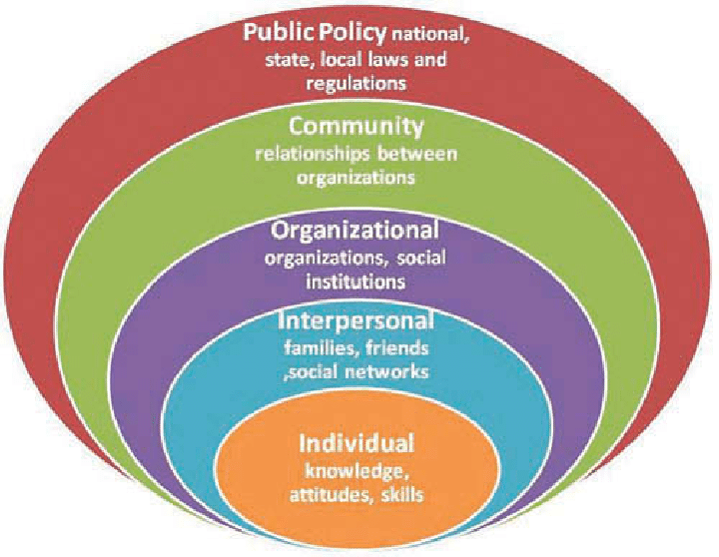

There is also the 8 Dimensions of Wellness Model (image 2).
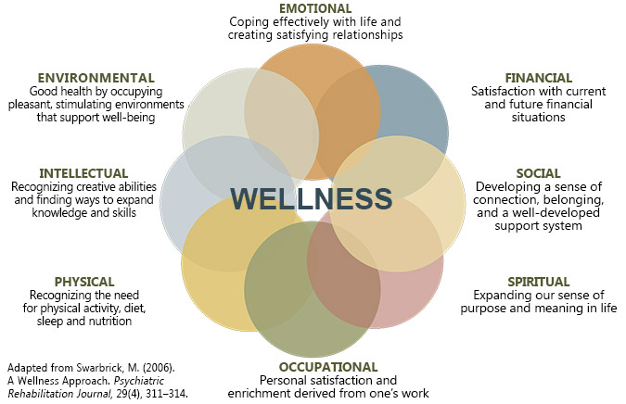

Sarah shared the 7 strategies for effective community change from CADCA’s National Coalition Institute. These 7 strategies are:
- Provide information
  - Pop-up events, brochures, billboards, forums, newsletters
- Enhance skills
  - Workshops, educational activities to increase skills of participants, such as refusal skills
- Providing Support for Prevention Activities
  - Creating opportunities to support people to participate in activities/strategies that reduce risk or enhance protection
- Enhancing Access/Reducing Barriers
  - Addressing systems that affect the ease, ability and opportunity to utilize available services and systems. This could look like transportation, housing, safety, and identifying barrier and strategies.
- Changing Consequences (Incentives/Disincentives)
  - Individual or business rewards for positive behavior, fines, revocation/loss of privileges or licenses.
- Changing Physical Design/Making Environmental Changes
  - Moving mini alcohol bottles away from impulse-buy sections in gas stations, tobacco free campus signs
- Modifying/Changing/Developing Policies
  - Establishment, community, local or statewide policies around substance use or access (ex. Drug free work places, safe service for bartenders).

- Shelley adjourned the August meeting at 10:30am, with additional time for networking and food. The previously scheduled Minimize Risk Maximize Life Training for September is CANCELLED. The next coalition meeting will be on September 7th from 9-10:30am to continue the work we did today!

Action Steps
- Volunteer for an upcoming event HERE!

Next Meeting
September 7th | 9:00-10:30am
Warren County Administration Building
406 Justice Drive, Room 128, Lebanon, OH 45036

